Prog starts from main

Parentheses mark start and end of args

“” defines string

Include name, class section, instructor name, and brief description in the comments at the beginning of a program

Indent 3-5 spaces

Java often uses end of line style

Int: integers

Double: real nums

Char: single text characters

Boolean: logical values

Variable: a piece of your computers memory that is given a name and type and can store a value

Declare variable <type> <name>; int x;

When tracing coded, draw boxes for variables

Assignment statement <name> = <value>

Final only declared once, for constants, if it is not going to change, name it in all caps

Variables and method names use lowercase, for several words use lower for first, capitalize first letter of second word

Class names use camel case

Int age = 18;

double height = 6.2;

char initial = ‘K’;

System.out.println(age);

System.out.println(height);

System.out.println(initial);

Header with name, class section, instructor, date, and brief description

Desc should explain, what prog does, its key features, supporting data structures, any unique techniques

User input

Create scanner obj

Scanner input = new Scanner(System.in);

Use the method nextDouble() to obtain a double value

System.out.print(“Enter a double value: “);

Scanner input = new Scanner(System.in);

double d = input.nextDouble();

make sure to import scanner

import java.util.Scanner;

nextByte()

nextShort()

nextInt()

nextLong()

nextFloat()

nextDouble()

% remainder

5 / 2 yields int 2

5.0 / 2 yields a double 2.5

5 % 2 yields 1

+= addition assignment I +=8 I = I + 8

-= subtraction assignment

++var preincrement increment var by 1, and use the new var in the statement int j = ++I // j is 2, I is 2

Var++ postincrement increment var by 1, but use the original var value in the statement int j = i++ // j is 1, i is 2

--var predecrement

Var—post decrement

\

Result of comparison is a boolean true or false

Boolean b = (1>2);

== equal to

!= not equal to

If booleanExpression

{

Statement

}

&& and

|| or

^ exclusive or, puts out false if both are true or both are false

If answer %5 == 0

{

System.out.print(“Divisible by 5”);

}

Switch (expression)

{

Case constant-1: statement

Case constant-2: statement

Default: statement

}

Break is used if you want to go to the end immediately

Switch expression should be char, byte, short or int

If (x > 0)

Y=1

Else

Y = -1

Is equiv to

Y= (x > 0) ? 1 : -1;

Bool express ? express1 : express2

Operatior precedence

Var++, var—

Decimal is base 10

Binary is base 2

Octal is groups of binary

Hexadecimal groups of binary

Byte= 8 bits

All 256 possible can be represented by 2 hex

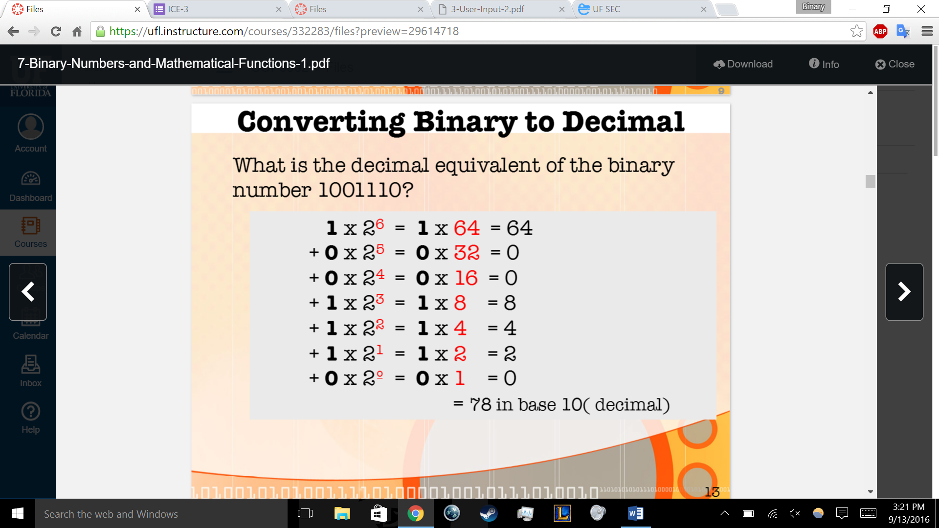

0+0=0

1+0=1

0+1=1

1+1=10

1+1+1=11

Overflow = an extra digit that cannot be represented by computer

Hex

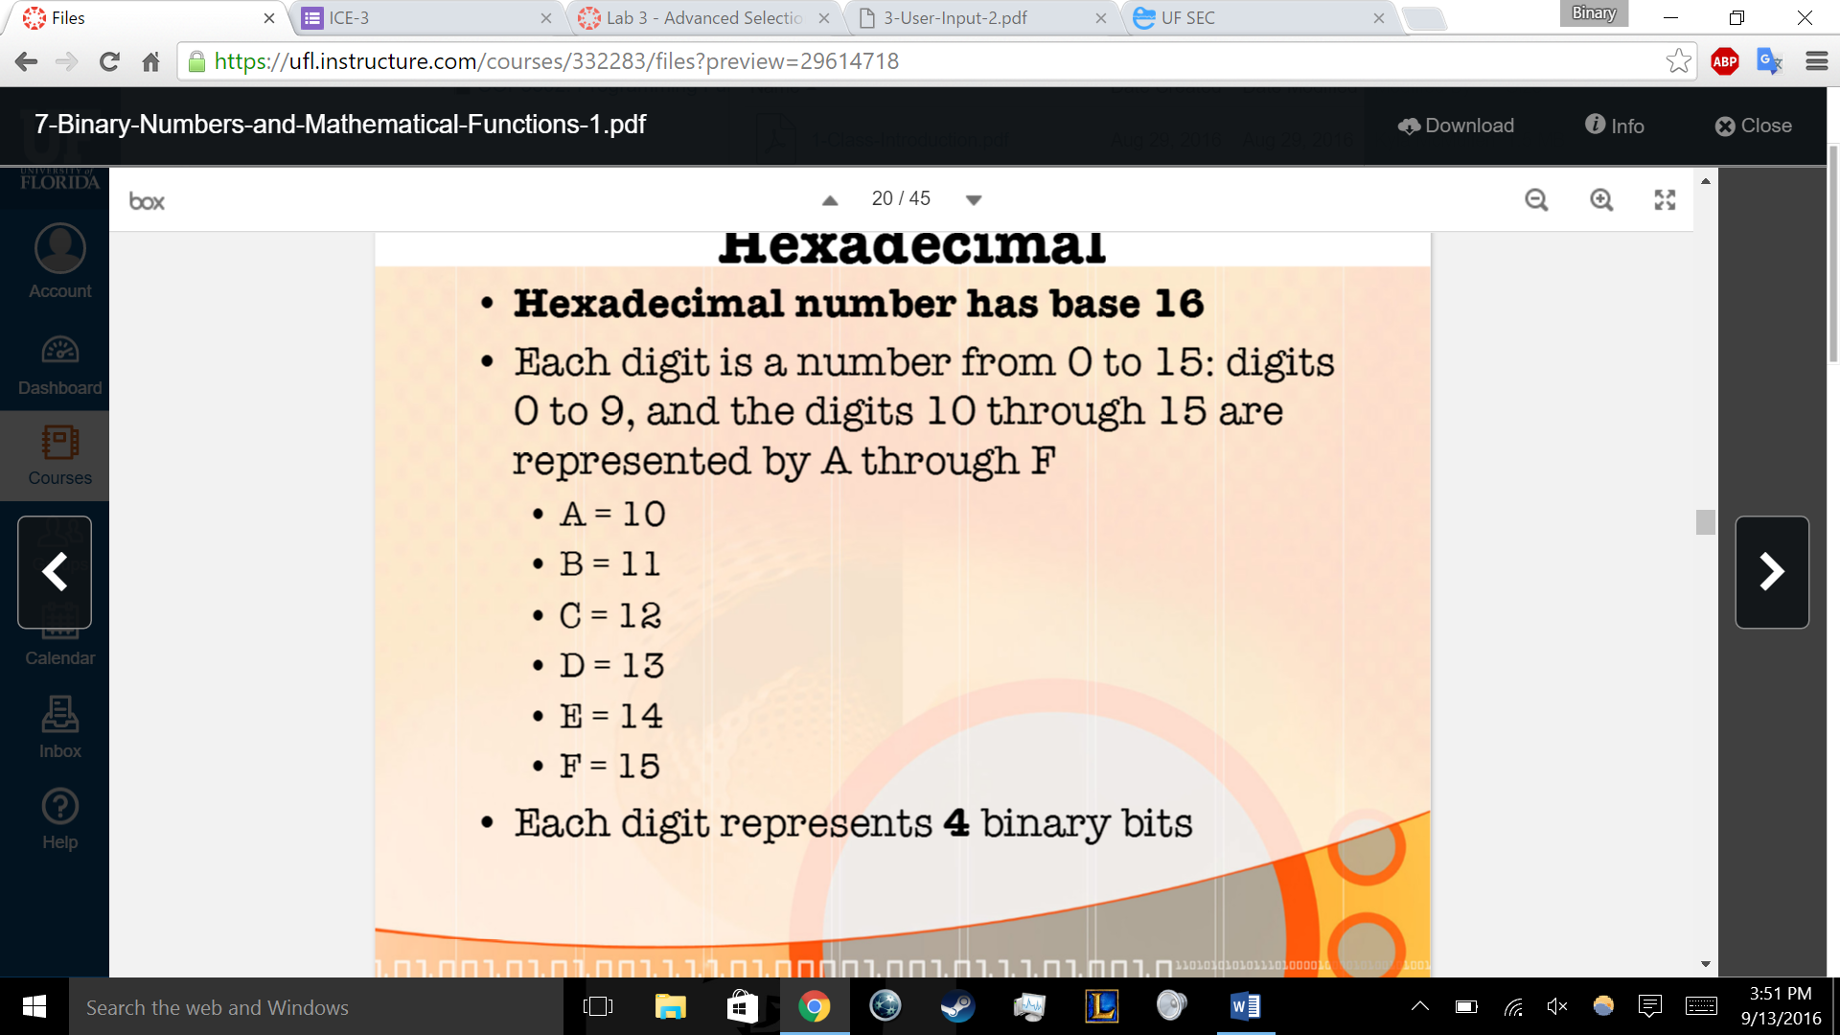

UNICODE IS ON TEST

Int I = ‘a’; // looks up the decmal code that a represents

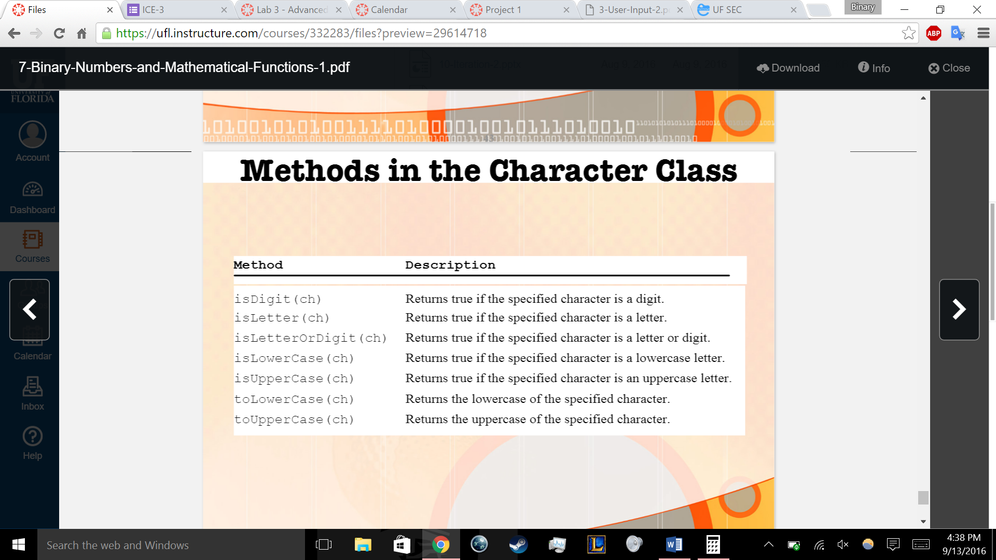

Strings

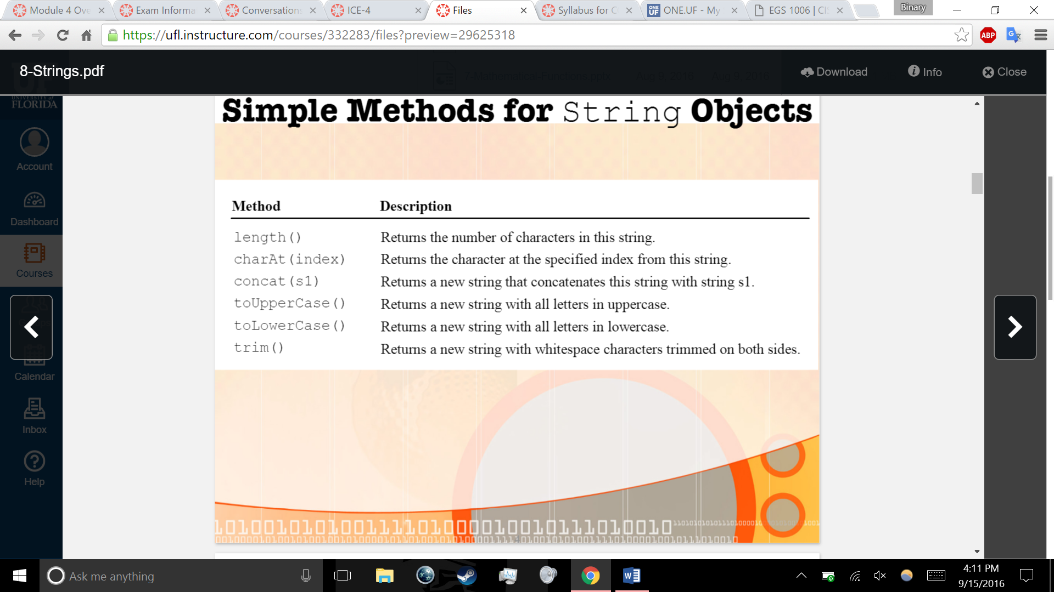

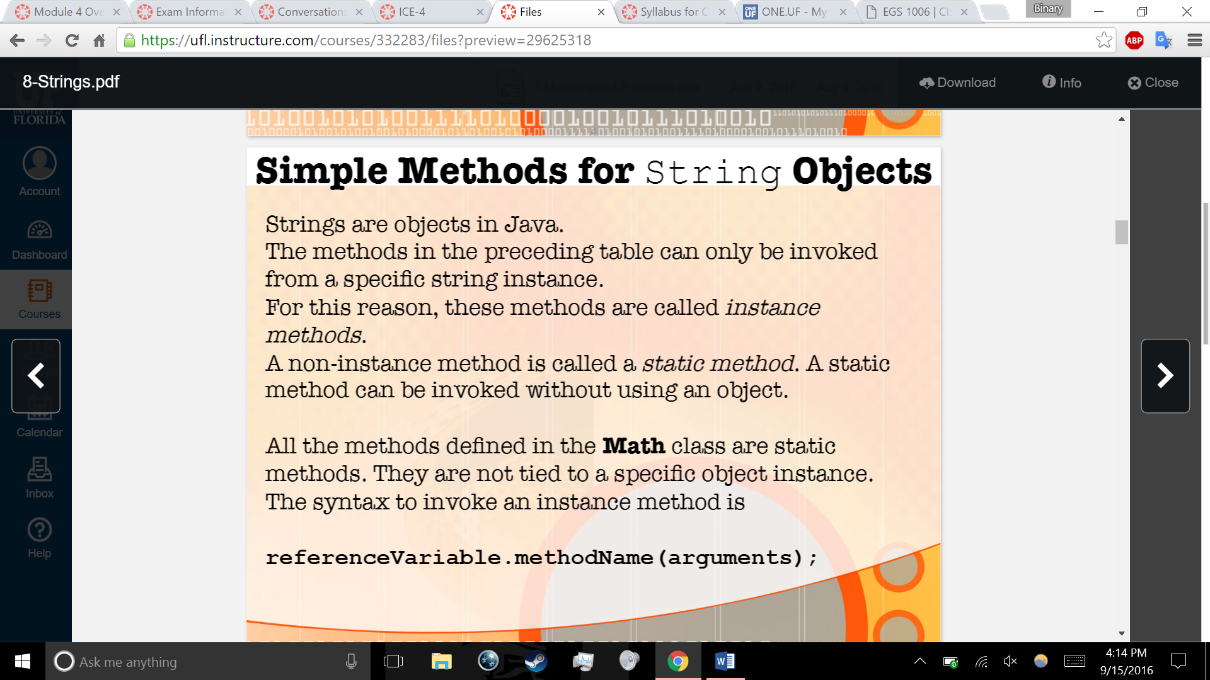

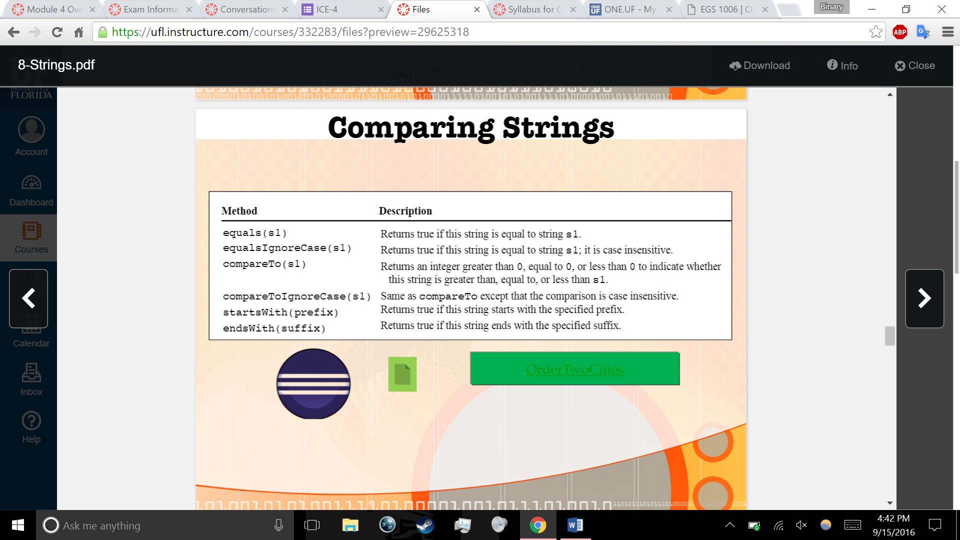

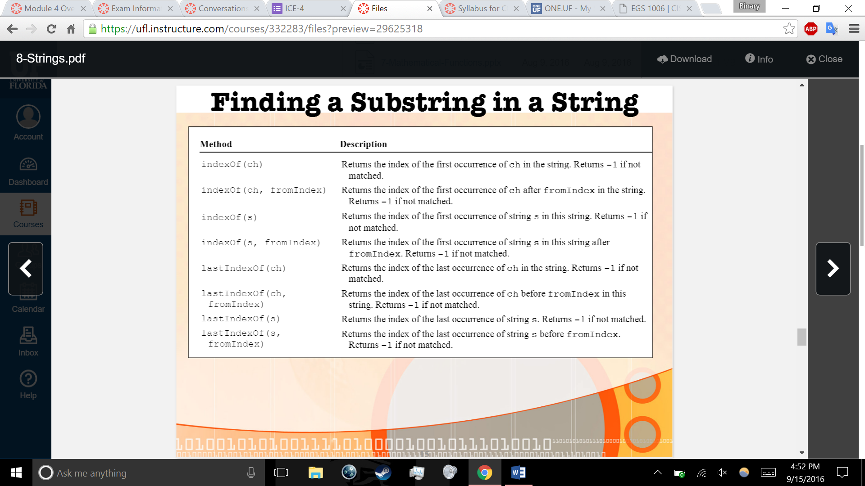

Strings iteration

System.out.printf(format, items);

Format is a string that may consist of substrings and format specifiers. Format specifier specifies

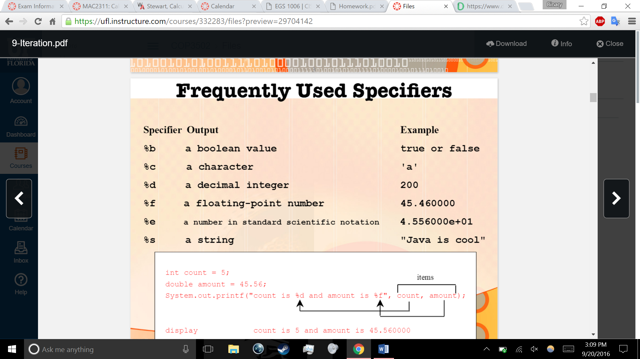

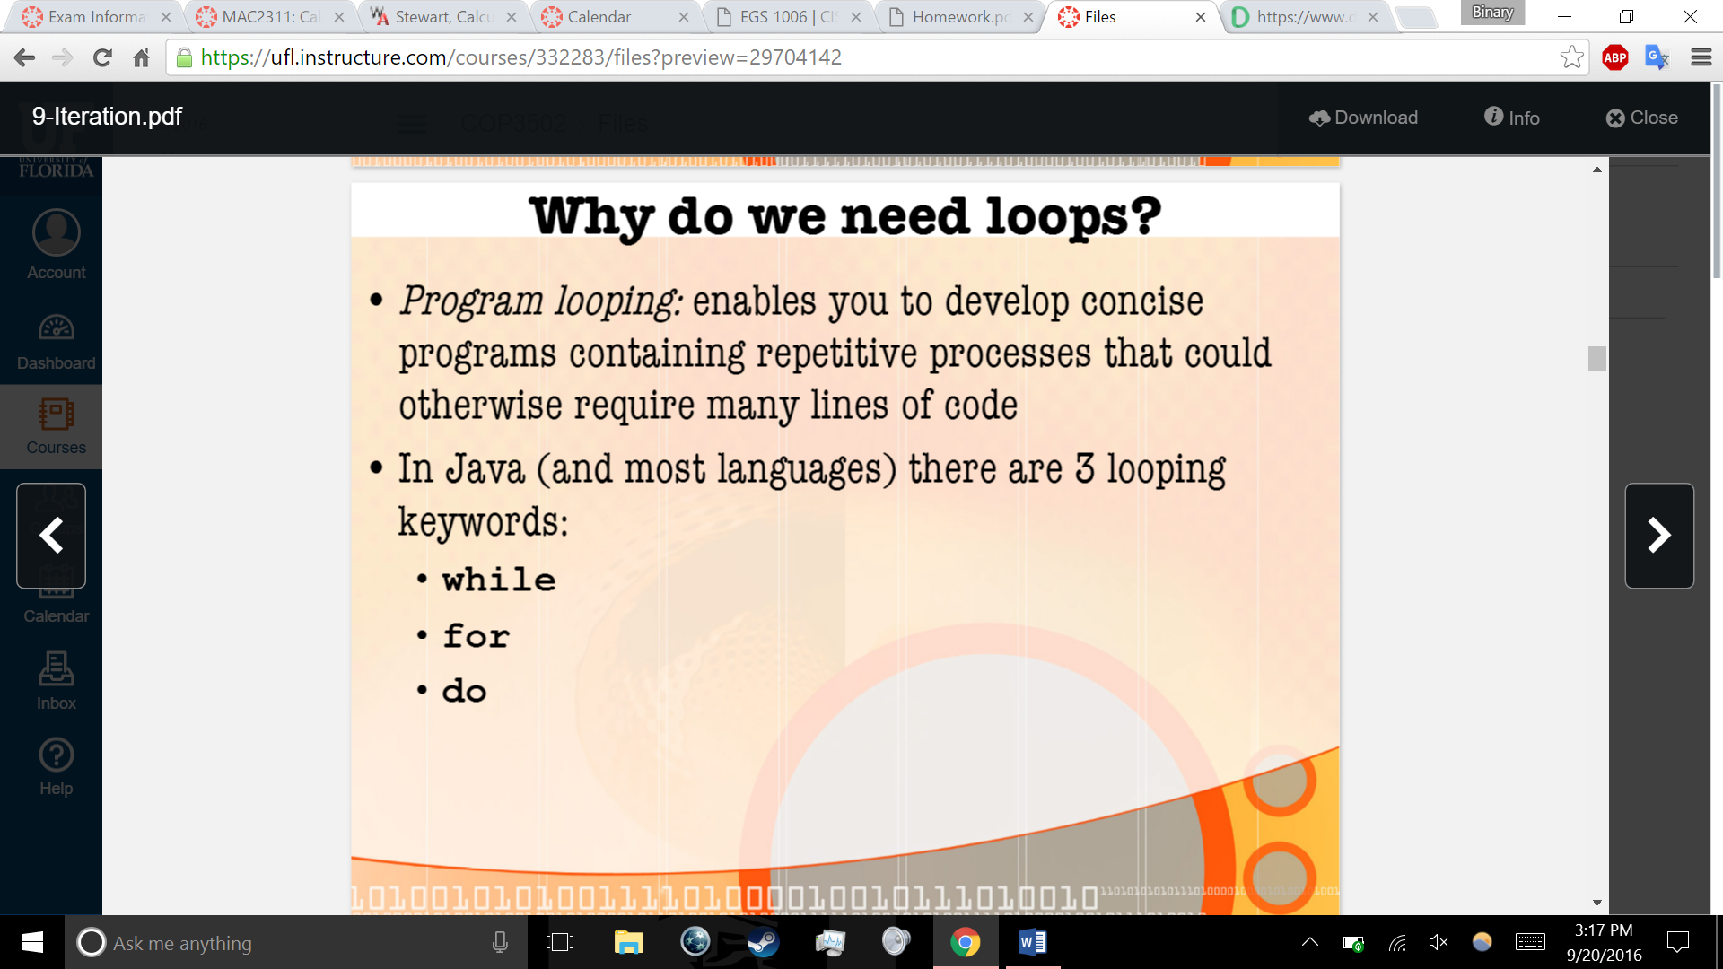

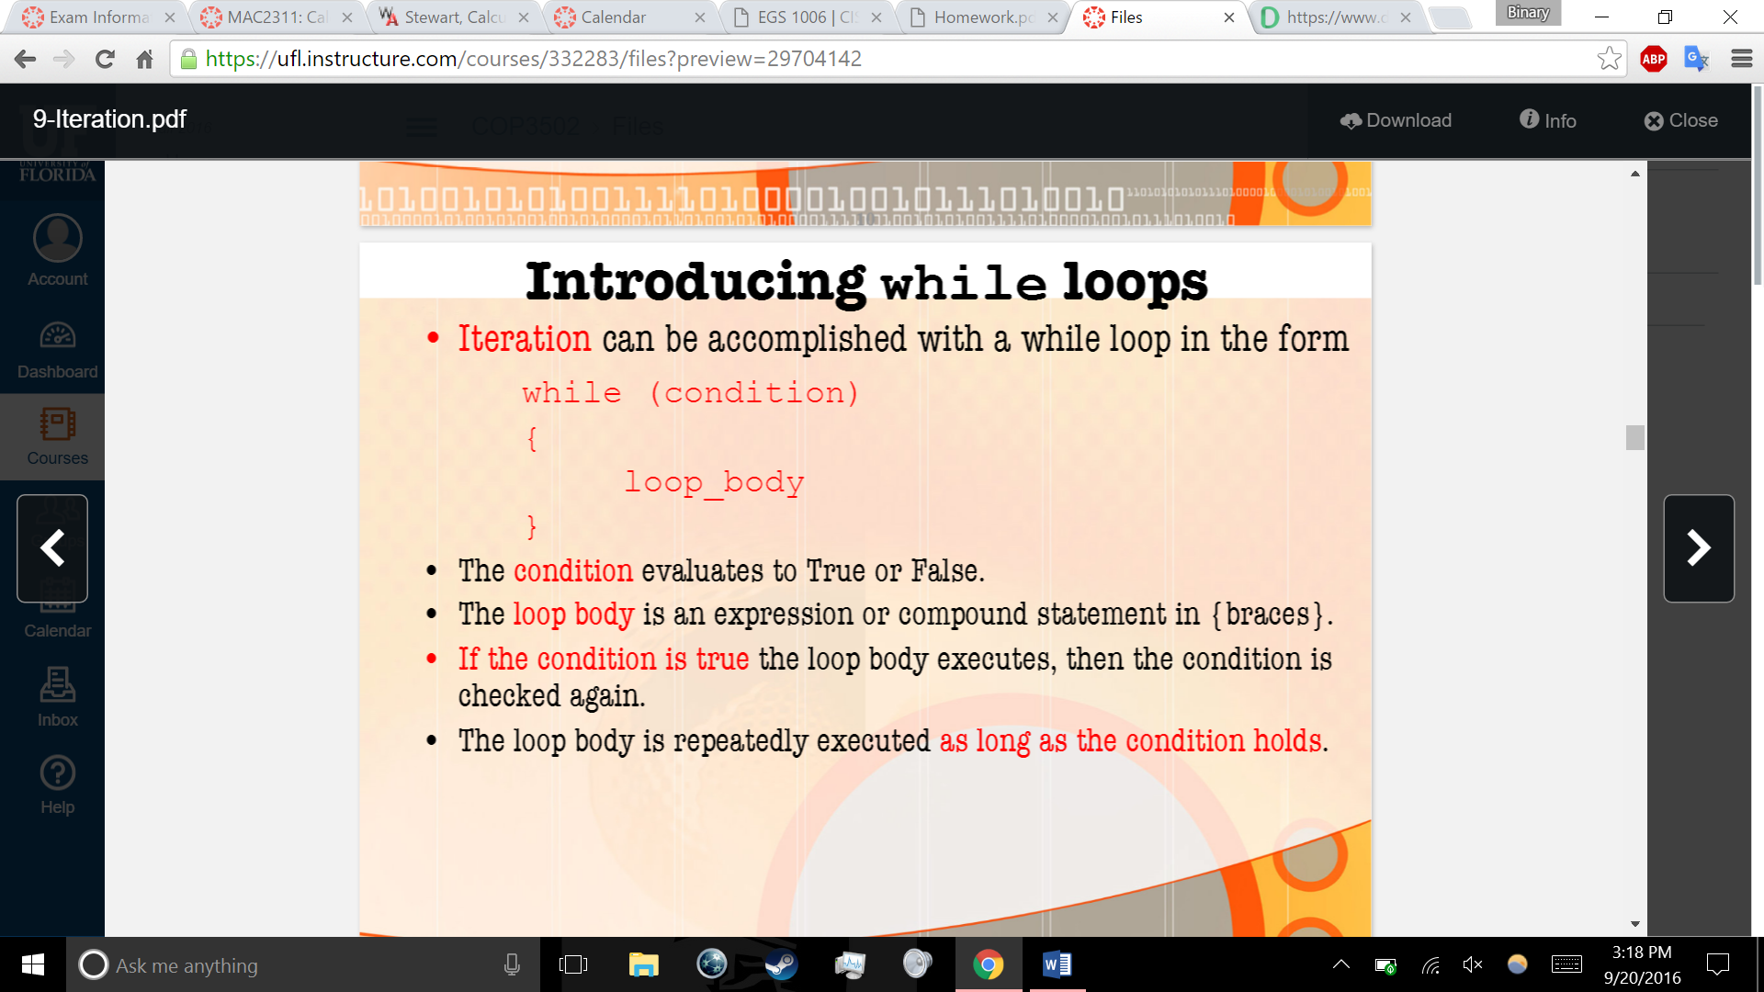

Iteration again

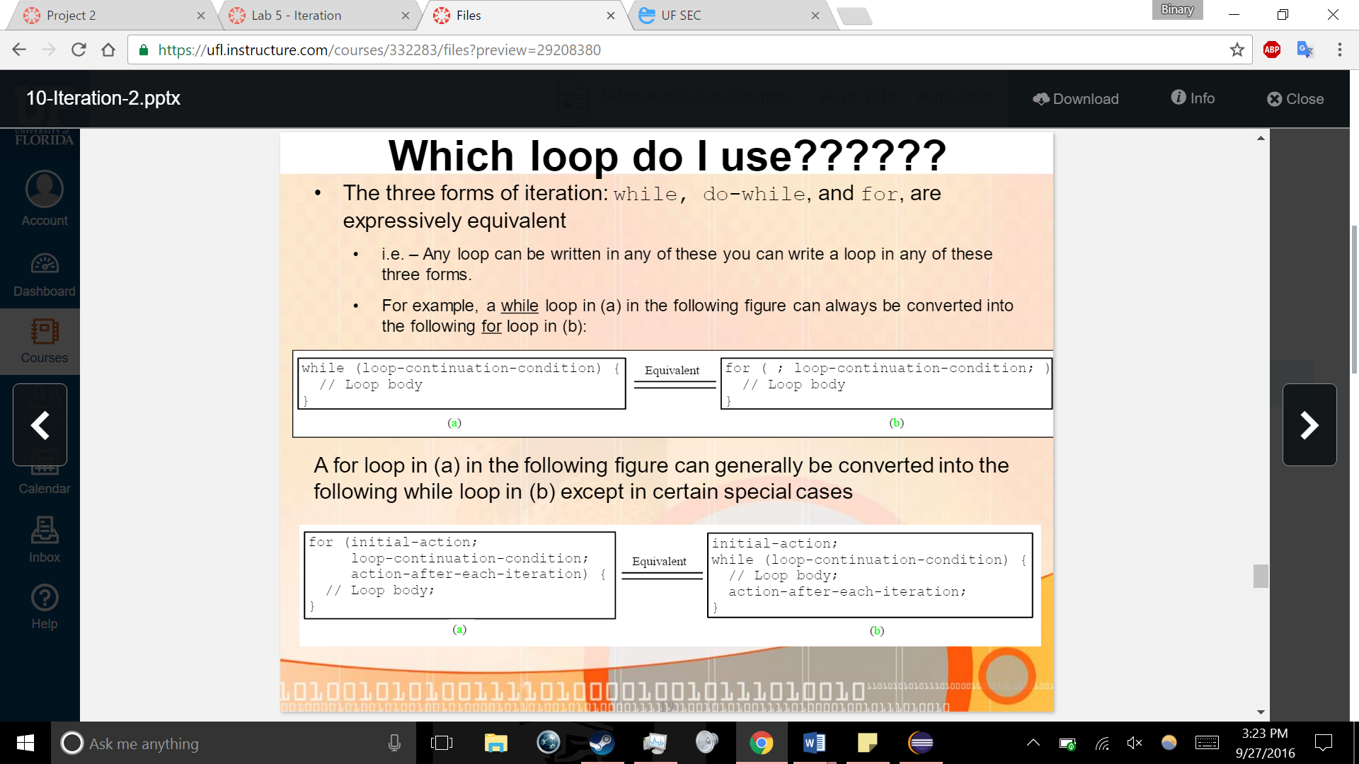

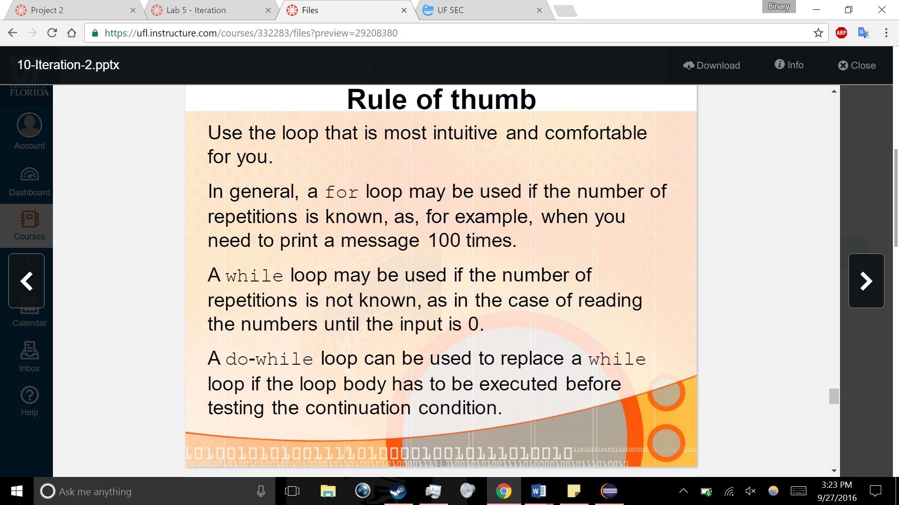

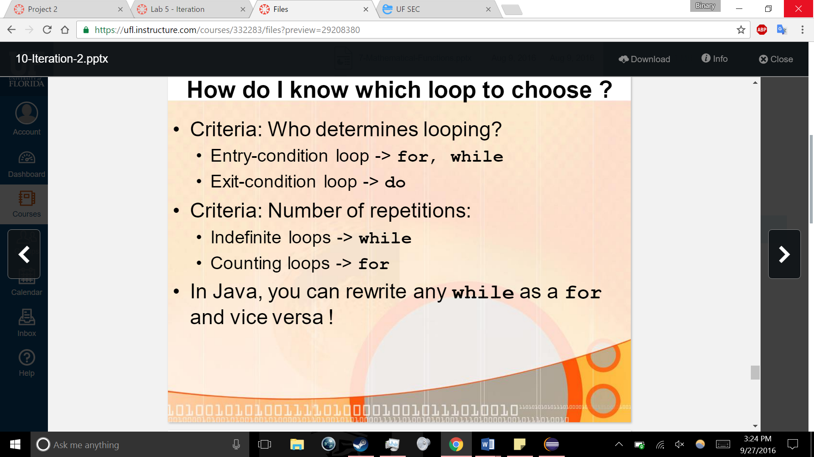

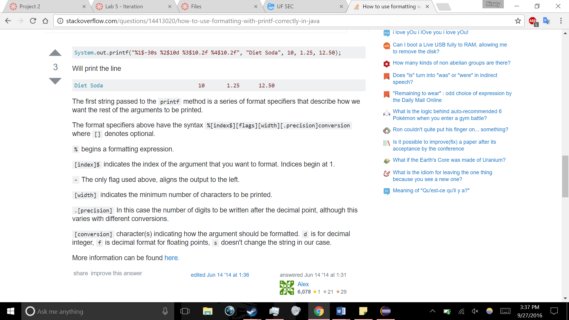

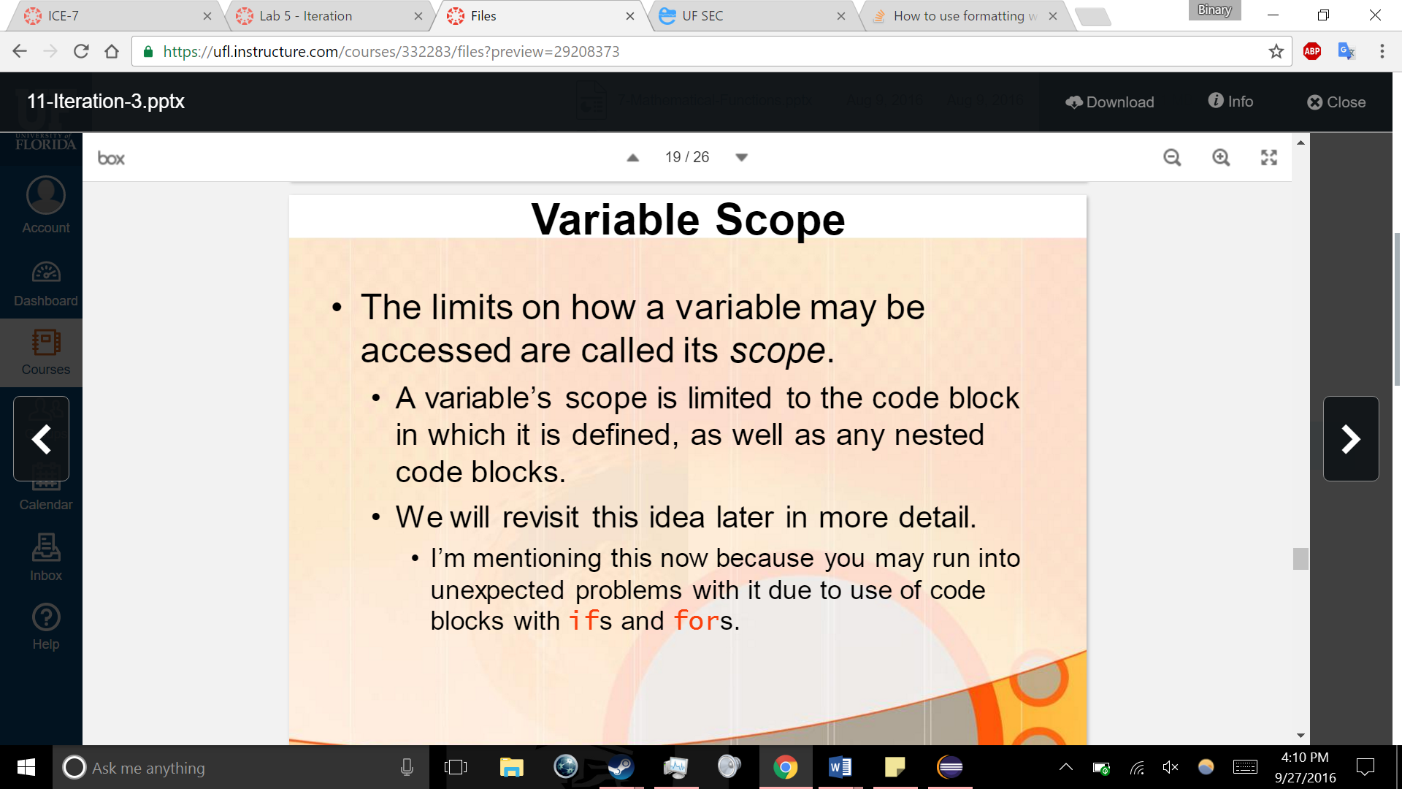

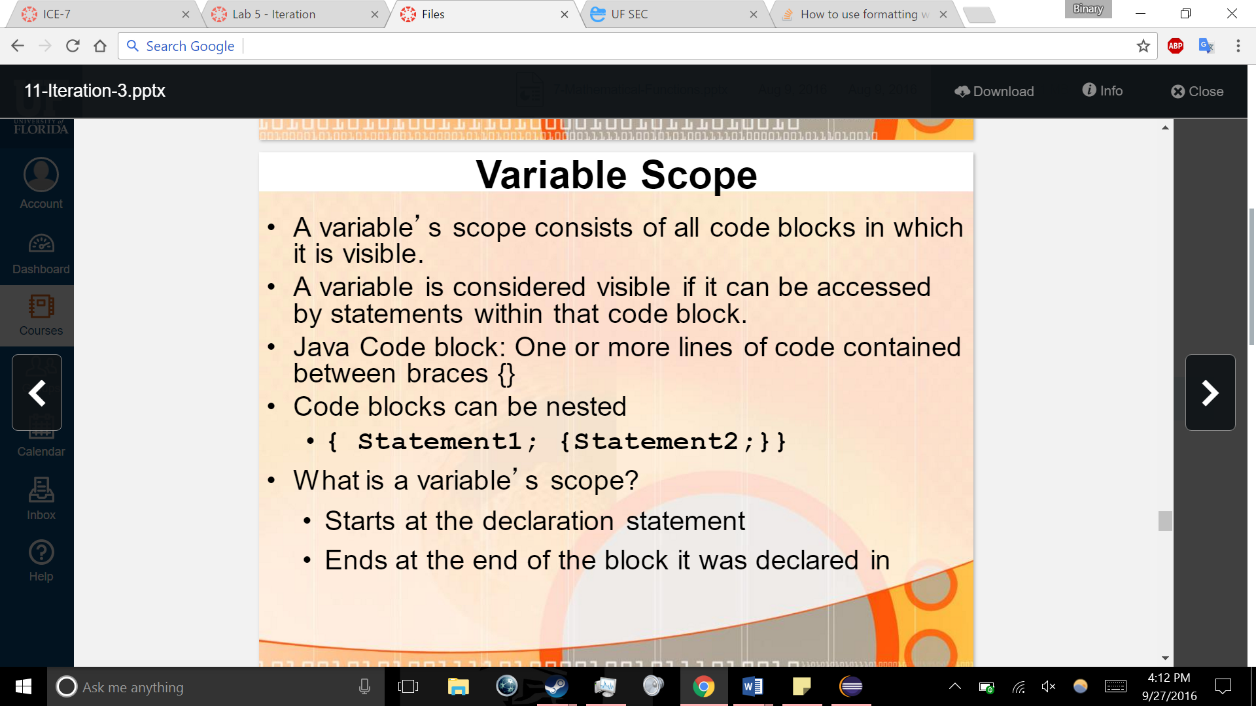

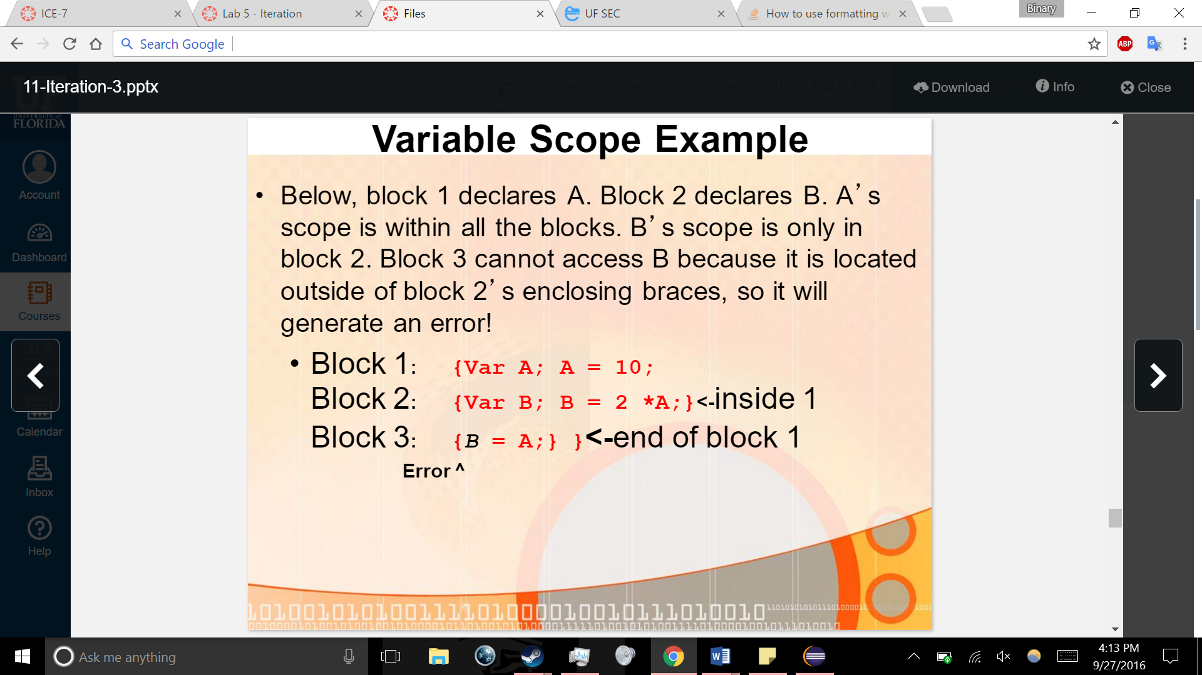

Review bits

10/2 cse A101 7 to 90

10/3 lit 0101

In front --x ++x it happens immediately

x—x++ is later

if doing comparisons x-- = 0, will compare before doing the minus

1+1 =10

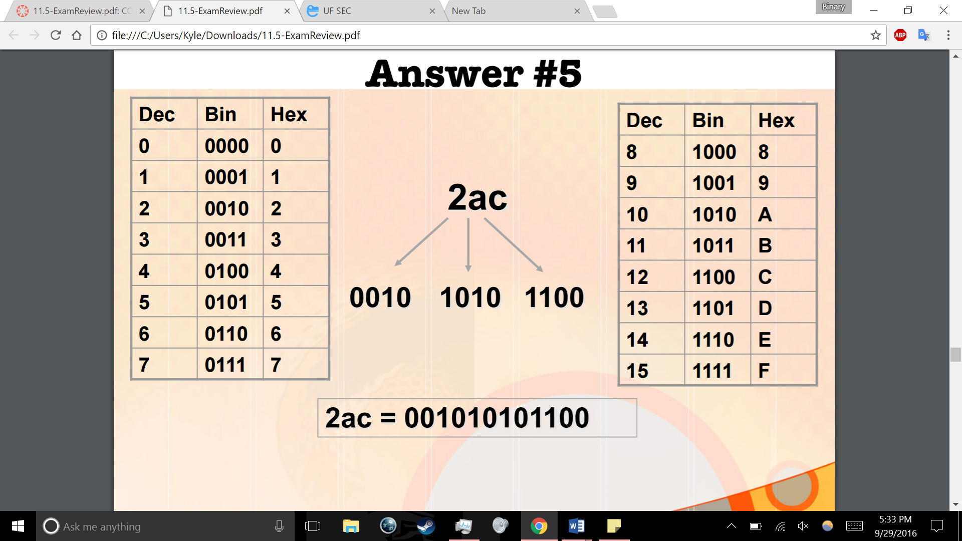

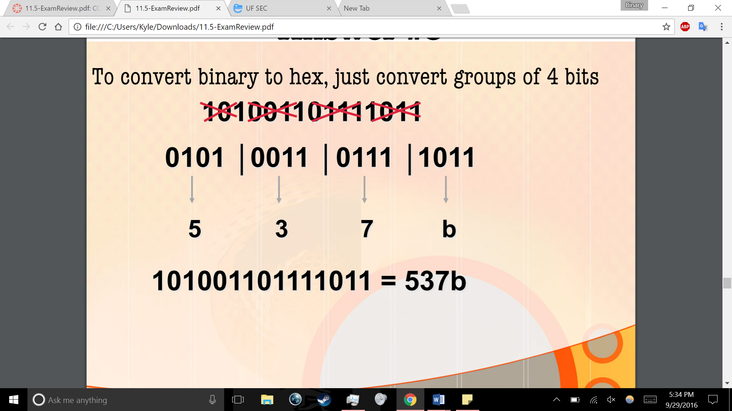

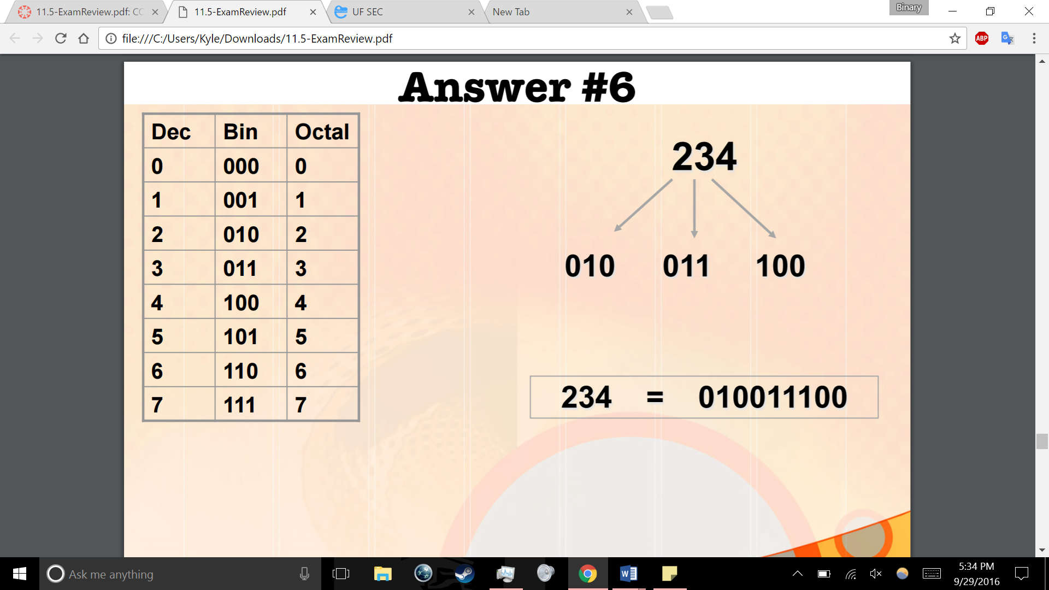

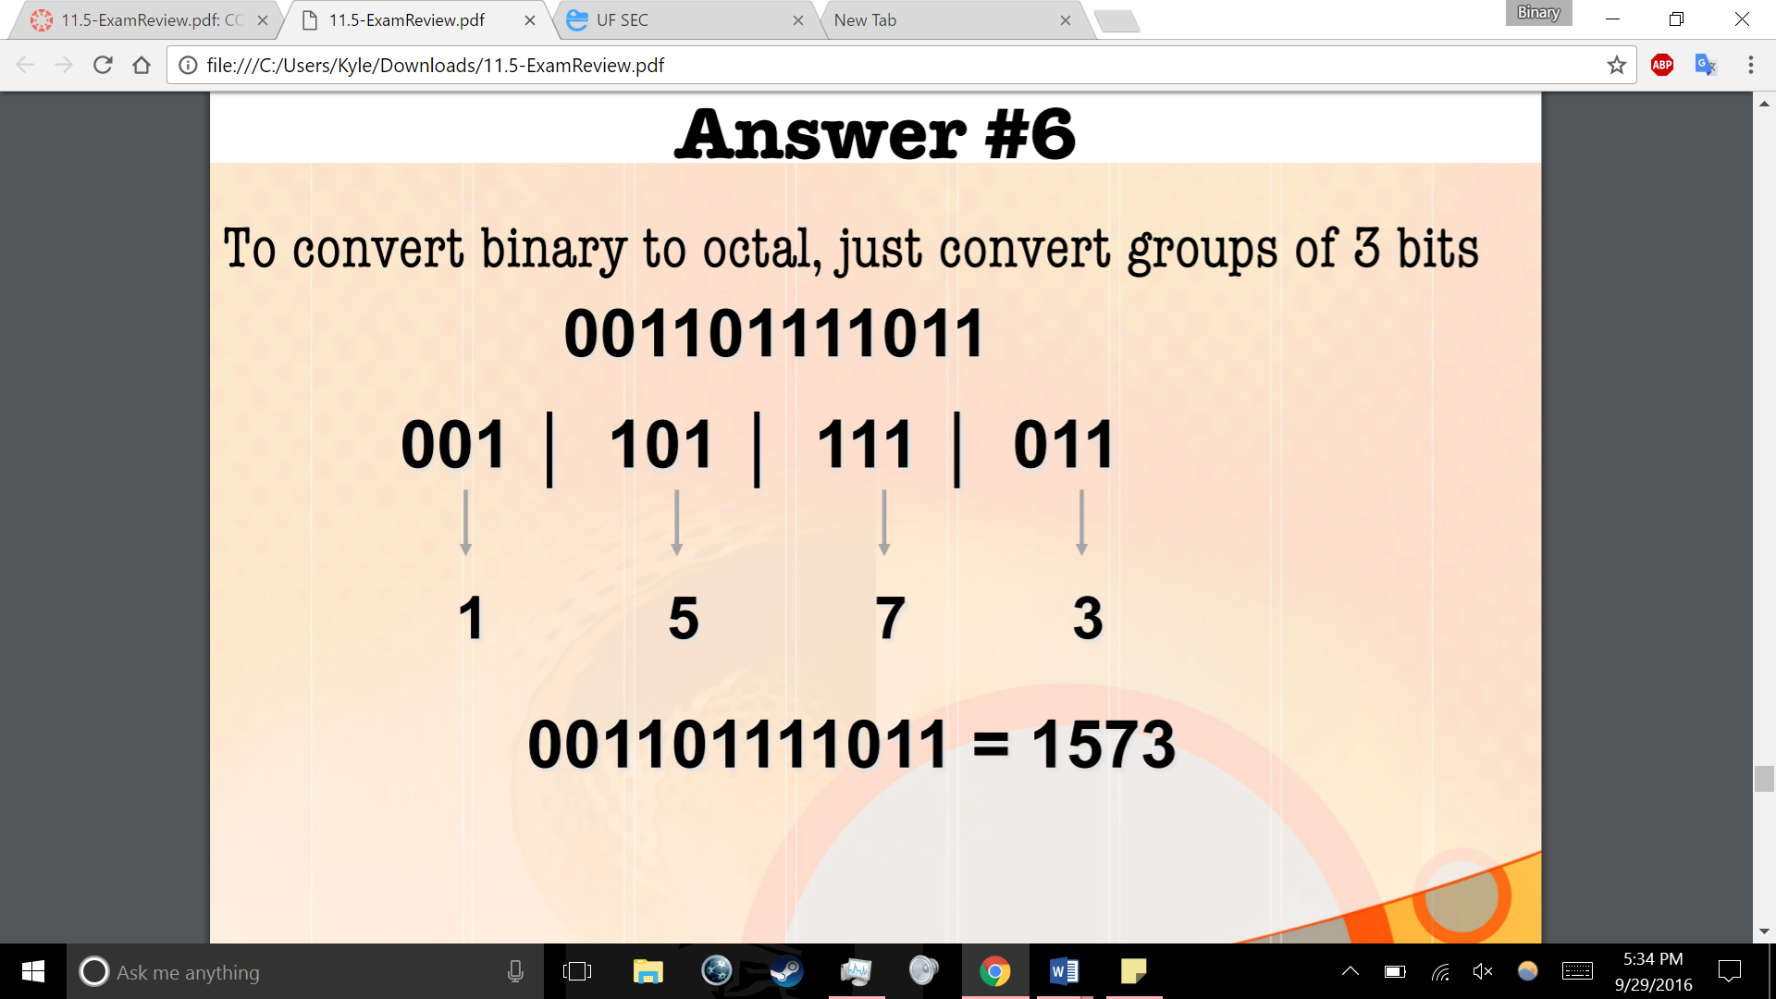

How to declare a string

String stringName = “”;

Or to use input from keyboard as string

String stringName = input.nextLine();

**IMPORTANT: when making comparisons with strings use stringName.equals (thingyouarecomparingto) not ==**

Substrings

String stringName2 = stringName.substring(index1, index2);

String stringName3 = stringName.substring(index1, index2);

String stringName4 = stringName2.concat(stringName3); adds the first to the second same as (stringName2 + stringName3)

Hard to add spaces in between with concat

Use = to set things equal to one another

**Use == for comparisons, not =**

Declare Booleans like

Boolean booleanName = true or false;

If structure

If (condition) no semicolon

{

Semicolons here tho

}

Else if/ else

System.out.println(“”);